ACID-BASE TITRATIONS

Titrations are a method for accurately determining the concentration of a substance.

There are two substances in a titration:
- A substance of known concentration (called a standard solution)
- A substance of unknown concentration

Today your teacher will demonstrate how this procedure could be used to find the concentration of a solution of HCℓ using a standard solution of NaOH

Steps: Data / Measurements:
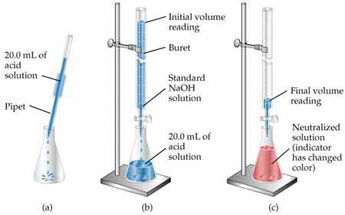
Concentration of standardised NaOH solution:

Initial volume NaOH:

Final volume NaOH:

Volume NaOH added to flask:

Calculate the number of moles of NaOH that were added to the flask.

The equation for this reaction is: HCℓ + NaOH H₂O + NaCℓ

Using your answer to the previous question, calculate the moles of HCℓ in the flask.

The flask contained 20.0 mL of HCℓ. Calculate the concentration of HCℓ in mol L⁻¹.

Primary Standards

To perform a titration, you need to have one solution of known concentration. These solutions can be prepared by dissolving a known mass of a suitable substance into a known volume of distilled water.

See diagram for example:
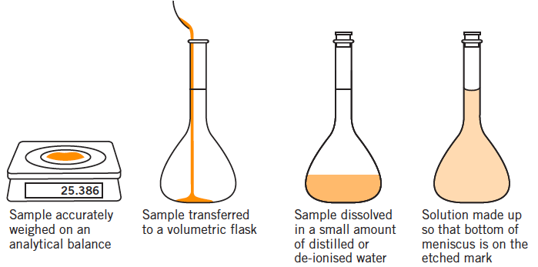

Let’s say that the above procedure was performed using anhydrous sodium carbonate (Na₂CO₃). In this hypothetical procedure, 4.231 g of Na₂CO₃ was adding to a 250 mL volumetric flask, and then the volumetric flask was filled with distilled water. What is the concentration of Na₂CO₃ in mol L⁻¹?

Only a few substances can be used to make a primary standard. Characteristics of primary standards include:
- Available with a high degree of purity
- Does not readily absorb water moisture from the air
- Has a relatively high molecular weight

For acid-base titrations, two common primary standards are anhydrous sodium carbonate (Na₂CO₃) and oxalic acid dihydrate (H₂C₂O₄.2H₂O).

Acids like HCℓ and H₂SO₄ cannot be obtained in pure form.

NaOH and KOH cannot be used as a primary standard because they are “deliquescent” – they readily absorb water moisture from the air. If you weigh 4.321 g of NaOH you won’t know how much is NaOH(s), and how much is absorbed water moisture.

Prac: Making a standard solution of Na₂CO₃

Before starting the experiment we should calculate how much mass of Na₂CO₃ we need to weigh. What mass of Na₂CO₃ would be needed to make 500 mL of 0.05 mol L⁻¹ solution?
(The molar mass of Na₂CO₃ is 105.99 g mol⁻¹)

Before the class:
Your teacher placed the Na₂CO₃ in an oven at 270 °C for 30 minutes to remove any water moisture, and then left the anhydrous Na₂CO₃ in a desiccator to cool. The desiccator contains silica gel crystals which absorb water moisture, preventing any water moisture from being reabsorbed by the Na₂CO₃.

Instructions:
- Rinse a 500 mL volumetric flask and lid with distilled water.

- Accurately weigh out into a 250 mL beaker a mass of Na₂CO₃ approximately equal to that calculated. You should not waste time trying to weigh out exactly the mass calculated. Any value within ±0.5 g of the target will be fine, so long as you correctly record the actual mass used.
Mass of Na₂CO₃ used: __________ g

- Dissolve the solid in ~100 mL of distilled water

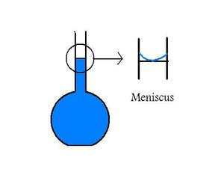
- Transfer this solution to a 500 mL volumetric flask. To ensure that all of the Na₂CO₃ has been transferred, rinse the beaker several times with about 20 mL portions of distilled water, adding each washing to the volumetric flask.

- Make up the solution to precisely 500.0 mL with distilled water, until the meniscus of the water level touches the etched line on the flask. Add the last few drops using a plastic pipette to ensure you do not overfill the flask.

- Place the stopper on the flask and invert the flask a few times to thoroughly mix the solution

- Calculate the concentration of your standard solution:

- Use a small amount of the solution to rinse a storage bottle. Then, transfer your solution to the storage bottle. Label it with your name, the type of solution and its concentration.
Using pipettes

Pipettes can be used to deliver a volume of solution with a high degree of accuracy. A 20 mL pipette can accurately deliver a volume of 20.00 ± 0.06 mL (i.e. a volume between 19.95 mL and 20.05 mL).

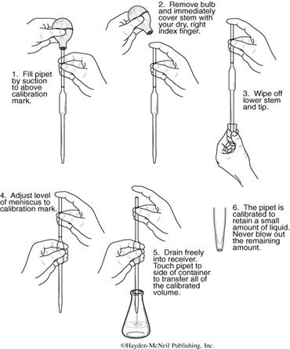

Prac: Using a pipette

Test your ability to deliver consistent volumes using a pipette.

- Weigh an empty beaker and record its mass
- Draw 20 mL of water using a volumetric pipette and add it to the beaker
- Reweigh the beaker, and calculate the mass of H₂O added

Repeat this a number of times, then calculate the average mass of water pipetted. Then, calculate the average volume of water pipetted. To do this, divide the mass by the density

 | Initial mass | Final mass | m(H₂O) added  Water temp (°C) Density (g mL⁻¹)  15 0.999099  16 0.998943  17 0.998774  18 0.998595  19 0.998405  20 0.998203  21 0.997992  22 0.997770  23 0.997296  24 0.997296  25 0.997044
1
2
3
4
5
6
7
8
9
10
 |  | Average: | g

$$Average volume=\frac{mass}{density}=\frac{ }{}=$$

Prac: Standardising a solution of HCℓ

HCℓ cannot be prepared as a primary standard because it cannot be obtained in pure form. However, we can standardise it (i.e. find its concentration) by titrating it against the Na₂CO₃ solution prepared earlier. This would make the HCℓ solution a secondary standard.

The reaction is: 2 HCℓ(aq) + Na₂CO₃(aq) 2 NaCℓ(aq) + H₂O(ℓ) + CO₂(g)

Equipment:
Solution of Na₂CO₃ (primary standard)
Solution of HCℓ (500 mL)
20 mL volumetric pipette
Burette and stand
Funnel
Methyl orange indicator
3x 250 mL conical flasks
2x 250 mL beaker
Distilled water
Method:

- Place about 100 mL of the standard Na₂CO₃ solution into a clean beaker. If the beaker is wet, rinse with a little of the Na₂CO₃ solution first

- Rinse a 250 mL conical flask with distilled water, and then rinse a clean 20 mL pipette with some of the Na₂CO₃ solution. Pipette a 20 mL aliquot of the Na₂CO₃ solution into the conical flask. Add 2-3 drops of your methyl orange indicator into the flask.

- Place about 100 mL of HCℓ into a clean beaker. Again, if necessary, rinse the beaker with a little of the HCℓ solution first.

- Rinse a clean burette with some of the HCℓ and then fill the burette with the solution.

- Note and record the level of acid in the burette. Obtain a rough estimate of the titration volume by running acid quickly from the burette while constantly swirling the liquid in the conical flask. Stop delivery of the acid as soon as a permanent colour change is obtained. Note and record the acid level in the burette and determine the approximate volume of acid required.

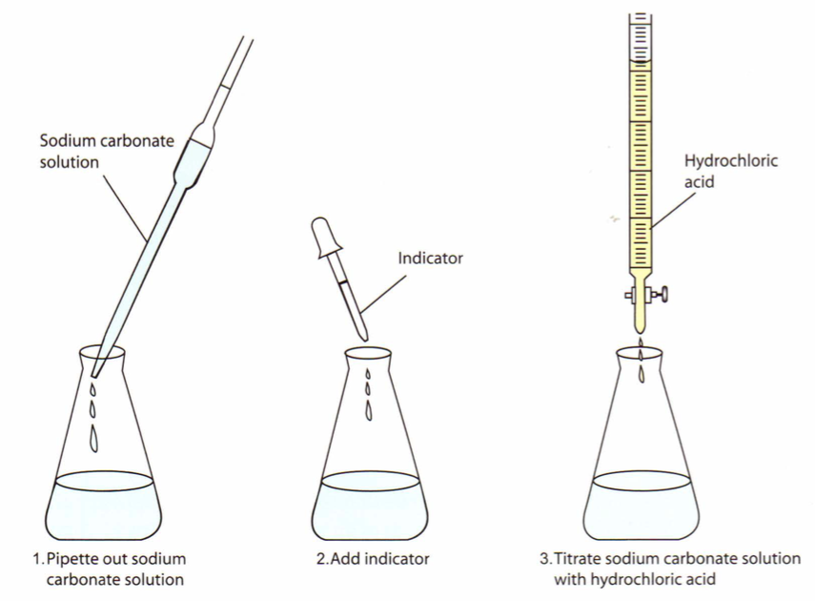

- Prepare another conical flask containing 20 mL of the Na₂CO₃ solution and 2-3 drops of indicator. This time add the acid quickly from the burette with constant swirling of the flask, until the volume added is within 2-3 mL of the approximate volume required. Rinse the inside of the conical flask with a jet of water from a wash bottle to return any splashed solution to the bulk. Continue adding acid drop by drop, and with constant swirling, until the addition of one drop is sufficient to produce a permanent colour change. Note and record the level of the acid in the burette at the end point.

- Repeat the accurate titration with further 20 mL portions of Na₂CO₃ solution until consistent titration volumes are obtained. These should be within 0.2 mL of each other.

Results

 | Rough estimate | Accurate titrations
 |  | 1 | 2 | 3 | 4 (if needed)
Initial volume (mL)
Final volume (mL)
Titration volume (mL)

Questions:
- Calculate the number of moles of Na₂CO₃ used in each titration.

- From the balanced chemical equation, determine the number of moles of HCℓ that react with each mole of Na₂CO₃. Use this to determine the number of moles of HCℓ used in the titration.

- Calculate the average volume of HCℓ used in the titrations. Use only those results that are reasonably consistent (i.e. within 0.2 mL of each other).

- Calculate the concentration of the HCℓ in mol L⁻¹.

Equivalence point and end point

The equivalence point is the point at which no more acid or base remain. In a 1:1 mole ratio reaction (e.g. NaOH + HCℓ) it would be when equal moles of each reactant have been added.

The end point is the point at which the indicator changes colour, signifying that we should stop the titration.

When we perform a titration we want to add just enough reactant from the burette to hit the equivalence point – no more and no less. By picking the correct type of indicator we can make these values very close together. e.g. the solution changes colour right when the equivalence point occurs.
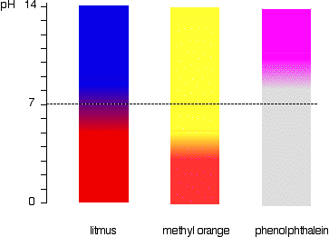


Common indicators

Methyl orange changes colour in the acidic pH range (between pH 3 and 5). The end-point colour is orange.

Phenolphthalein changes colour in the basic pH range (between pH 8 to 10). The end-point is pale pink.

Over the new few examples we will explore which indicator would be appropriate for different titrations.

Strong acid + Strong base HCℓ + NaOH NaCℓ + H₂O

In a titration between a strong acid and a strong base, the products are both neutral.

Imagine we were performing the titration with NaOH in the flask and HCℓ in the burette. If we measured the pH of the mixture in the flask as more acid was added, we would get a graph like the one below. It would start of basic, but become more and more acidic as HCℓ is added.

As we get very close to the equivalence point the pH changes very suddenly. It drops from pH 10 to pH 4 with the addition of only 0.1 mL of HCℓ.

The coloured bars show the pH that phenolphthalein and methyl orange change over. Because the pH changes suddenly near the equivalence point, both of these indicators would have changed colour at the same time as the equivalence point. You could use either indicator for this reaction.
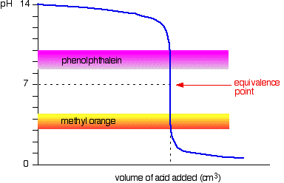

Strong acid + Weak base HCℓ + NH₃ NH₄Cℓ + H₂O

The reaction between HCℓ and NH₃ forms ammonium chloride, but ammonium chloride is not neutral. Ammonium ions undergo hydrolysis to produce an acidic solution.
NH₄⁺(aq) + H₂O(ℓ) ⇌ NH₃(aq) + H₃O⁺(aq)

This means the solution will have an acidic pH when it hits the equivalence point.

The graph below shows the pH changes as HCℓ is added to NH₃.
Note that the equivalence point occurs at ~pH 5 due to the acidic NH₄⁺ ion.
If phenolphthalein was used, the solution would begin changing colour much too early. The endpoint would occur well before the equivalence point. This means it is inappropriate for this titration.

If methyl orange was used, it would change colour at approximately the same time as the equivalence point. This means it is appropriate for this titration.
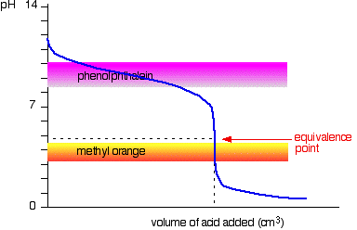

Weak acid + Strong base CH₃COOH + NaOH NaCH₃COO + H₂O

The reaction between CH₃COOH and NaOH forms sodium acetate, but acetate ions undergo hydrolysis to produce basic solutions…
CH₃COO⁻(aq) + H₂O(ℓ) ⇌ CH₃COOH(aq) + OH⁻(aq)

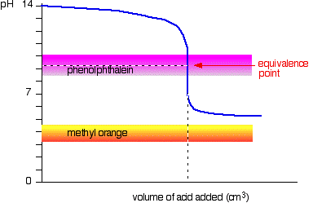
If phenolphthalein was used, the solution would change colour at the same time as the equivalence point. It would be a good indicator for this reaction.

If methyl orange was used, it would change colour much too late. (In fact, this graph indicates it might not change colour at all!) It would not be suitable for this reaction.

Make sure you know what indicators to use for which types of reactions, and be able to explain why. Being able to sketch graphs like these can really aid in your explanations.
Rinsing

During the previous experiment, you had to rinse certain glassware with certain solutions.

Step | Reason
The pipette used to collect Na₂CO₃ was rinsed with a solution of Na₂CO₃ | If we had rinsed the pipette with water instead, then there would be some drops of water left in the pipette. This would have diluted the Na₂CO₃ solution.  Part of the calculation to find n(HCℓ) was calculating:  n(Na₂CO₃) = c x V  If the Na₂CO₃ had been diluted by water in the pipette then…  - There would be less moles of Na₂CO₃ in the flask  - Less volume of HCℓ would need to be added to the flask  - We would overestimate the concentration of HCℓ
The conical flask was rinsed with distilled water before the 20.00 mL of Na₂CO₃ was added | The purpose of the pipette was to collect exactly 20.00 mL of Na₂CO₃. We already know how many moles of Na₂CO₃ are in the pipette (n = c x V).  If we had rinsed the conical flask with Na₂CO₃ then…  - There would be excess moles of Na₂CO₃ in the flask  - More volume of HCℓ would need to be added to the flask  - We would underestimate the concentration of HCℓ  Adding extra water to the conical flask would not in any way affect the number of moles of Na₂CO₃, and would have no effect on the results.
The burette was rinsed with HCℓ | Similar to the pipette, if we had rinsed the burette with water then there would be some drops of water left in the burette. This would have diluted the HCℓ solution.  If the HCℓ solution was diluted then we would have needed a greater volume of HCℓ to react with the Na₂CO₃ solution. This means that we would have underestimated the concentration of HCℓ when calculating c(HCℓ) = n / V.

As a general guideline:
- Pipettes, burettes and storage bottles are rinsed with the solution they will contain
- Conical flasks and volumetric flasks get rinsed with distilled water

It is important that you know what to rinse each piece of glassware with. One type of exam question might be to write a procedure for performing a titration. Your procedure should mention what each piece of glassware should be rinsed with.

Another type of exam question could be to explain the effects of incorrect rinsing procedures. Make sure that you understand the logic used in the above three examples, as this is the sort of mental working (and explanation) that you would need to be able to re-create in an exam.

Accuracy and precision

- Accuracy refers to how close your value is to the true value.
- Precision refers to how consistent your results are.

The following image shows a depiction of accuracy and precision in archery.
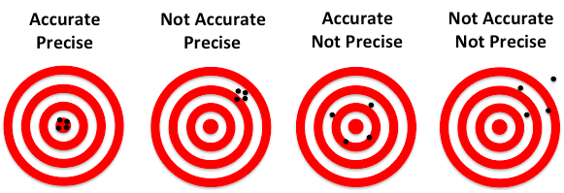

These concepts can be applied to titrations.

Imagine that for a particular titration, the correct titre volume is 18.21 mL.
The following are results from three students:

 | Titre Volume (mL)
 | Trial 1 | Trial 2 | Trial 3 | Average
Student A | 17.64 | 17.67 | 17.66 | 17.657
Student B | 17.04 | 18.20 | 17.33 | 17.523
Student C | 18.23 | 18.21 | 18.23 | 18.223

Student A is precise (consistent results) but inaccurate (not close to the correct answer).
Student B is imprecise (large variation in results) and inaccurate (not close to correct answer).
Student C is both precise (consistent) and accurate (correct).

Systematic errors

Systematic errors cause your results to be consistently higher or consistently lower than the correct value.

Examples of systematic errors might be:
- Always using the wrong indicator
- Always rinsing the pipette or burette with water
- Always measuring from the top of the meniscus when using a pipette

Systematic errors could explain how Student A achieved results that were precise but inaccurate. e.g. perhaps every time they rinsed the pipette with water before using it, which diluted the solution going into the conical flask and meant they needed less volume of solution form the burette.

Most systematic errors in titrations can be eliminated with proper technique.

Random errors

Random errors cause inconsistent results. Sometimes it will make your answer higher than the correct value, and sometimes it will make your result lower than the correct value.
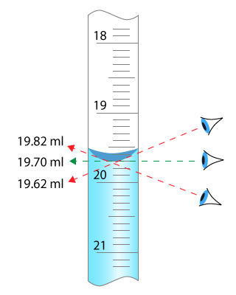
Some random errors are caused by user error. For example, volumes of solution should be read at eye-level, but someone might sometimes look from above eye-level and look from below eye-level. This means sometimes the measured volume would be too large and other times it would be too small.

Random errors can never be fully eliminated, even when using information with the correct technique. There are limitations to the accuracy of equipment itself and the ability of the people. Consider measuring burette volumes – there is a limit to how accurately you can read volumes using the scale on the burette.

The effects of random errors can be minimised by performing repeat trials, removing obvious outliers, and averaging the rest of the results.

Equipment | Uncertainty
20 mL pipette | ± 0.06 mL
Burette (2 readings) | ± 0.10 mL
250 mL vol. flask | ± 0.12 mL
500 mL vol. flask | ± 0.20 mL
2 d.p. mass balance | ± 0.01 g
Uncertainty

Uncertainty values are a measure of the random error inherent in equipment. For example, pipettes can deliver of volume of 20.00 ± 0.06 mL. The “± 0.06 mL” is the uncertainty of the pipette. Regardless of how correctly you use the pipette, this is the limitation to its accuracy.

It is possible to calculate the total uncertainty for a titration.
To do this, find the percentage uncertainty for each step, and add up the percentages.

Example:
Joey performs a titration using NaOH and HCℓ. Before performing the experiment he dilutes the HCℓ by pipetting 20.00 mL into a 250 mL flask, and then makes the volume up to 250 mL. He adds this solution to the burette. He then pipettes 20.00 mL of NaOH into a conical flask, and performs the titration. It takes an average of 14.20 mL of HCℓ to neutralise the NaOH. From this, he calculates the concentration of HCℓ is 1.2572 mol L⁻¹.

The uncertainty can be calculated by…

Equipment Measurement Percentage uncertainty
Pipette HCℓ 20.00 ± 0.06 mL 0.30%
Vol. flask 250.00 ± 0.12 mL 0.048%
Pipette NaOH 20.00 ± 0.06 mL 0.30%
Titre volume 14.20 ± 0.10 mL 0.70%
Total: 1.348%

1.348% of 1.2572 is 0.02 mol L⁻¹. (The uncertainty only gets written to 1 significant figure)

Therefore, the concentration of HCℓ should be written as… 1.26 ± 0.02 mol L⁻¹
Uncertainty (continued)

Fill in the following table to show the uncertainty associated with the Na₂CO₃ solution you prepared.

Equipment | Measurement | Percentage uncertainty
Mass balance
Volumetric flask
 |  | Total:

Write the concentration of your Na₂CO₃ solution to the correct number of decimal places, including the uncertainty.

______________________________ mol L⁻¹

Fill in the following table to show the uncertainty associated with the HCℓ solution you standardised.

Note that you to find the concentration of the HCℓ solution, you used the Na₂CO₃ solution
which already had a degree of uncertainty. Next to Na₂CO₃ concentration in the table, write
the percentage uncertainty you calculated earlier.

Equipment / Solution | Measurement | Percentage uncertainty
Na₂CO₃ concentration
Pipette Na₂CO₃
Titre volume HCℓ
 |  | Total:

Write the concentration of your HCℓ solution to the correct number of decimal places, including the uncertainty.

______________________________ mol L⁻¹

Standardisation of NaOH

Use your HCℓ solution from the previous experiment to standardise a solution of NaOH. Perform the titration with the hydrochloric acid in the burette and NaOH in the conical flask.

In this experiment you will need to…
- Rinse the pipette with: _____________________
- Rinse the conical flask with: ____________________
- Rinse the burette with: ____________________

Results:
 | Rough estimate | Accurate titrations
 |  | 1 | 2 | 3 | 4 (if needed)
Initial volume (mL)
Final volume (mL)
Titration volume (mL)

Calculations: Give the concentration of NaOH, including the uncertainty in your result.

Dilutions
Sometimes one of the solutions in a titration will be too concentrated, and will need diluting. In such cases you will often need to calculate the concentration of the original (undiluted) solution.

You can use the following formula to do this:
$$c_{1}{ × V}_{1}=c_{2}{ × V}_{2}$$

c₁ and V₁ are the concentration and volume of the original (undiluted) solution, and c₂ and V₂ are the concentration and volume of the diluted solution.

This can be rearranged to give:
$$c_{1}=c_{2} × \frac{V_{2}}{V_{1}}$$

Example:
A student analysed the ethanoic acid concentration in a commercial brand of vinegar. To do this, a 25.0 mL sample of the vinegar was diluted to 500.0 mL in a volumetric flask. 20 mL aliquots of the diluted vinegar were analysed by titration and found to have an ethanoic acid concentration of 0.0429 mol L⁻¹. Determine the concentration of ethanoic acid in the original undiluted vinegar.

$$c_{1}=\frac{c_{2}{ × V}_{2}}{V_{1}}=0.0429 × \frac{500}{25}=0.858 mol L^{-1}$$

Analysis of ammonia content in household ammonia

Household ammonia is approximately 3% by mass ammonia (~2 mol L⁻¹). This is too concentrated to be analysed with your standardised HCℓ solution (~0.1 mol L⁻¹).

Dilute 20.0 mL of household ammonia into a 500 mL volumetric flask to obtain a solution that is approximately 0.08 mol L⁻¹. Then, titrate your diluted solution against your standard HCℓ solution. Perform your titration with the ammonia solution in the burette.

Which indicator would be suitable to use in this reaction? ______________________

When diluting the NH₃ solution…
- What will you rinse the 20 mL pipette with? ____________________
- What will you rinse the volumetric flask with? ____________________

When performing the titration
- What will you rinse the pipette with? Water (to get rid of the NH₃) and then __________
- What will you rinse the burette with? ____________________
- What will you rinse the conical flask with? ____________________

Results (for ammonia titration):

 | Rough estimate | Accurate titrations
 |  | 1 | 2 | 3 | 4 (if needed)
Initial volume (mL)
Final volume (mL)
Titration volume (mL)

Calculations:

Calculate the concentration of the dilute ammonia solution (in mol L⁻¹)

Calculate the concentration of the original (undiluted) ammonia solution (in mol L⁻¹).
Include the uncertainty in your final answer.

The uncertainty for each measurement of the burette is 0.05 mL, but to measure the titre volume you make two measurements, giving a combined uncertainty of ± 0.10 mL

